Project Closure and Recap Form

This form should be completed after reaching the final milestone and upon completing your project at the end of the semester. A single form must be submitted by each team.

First, please fill the following entries with information about your project:

- Group #: 3
- Group Members: Alex Tsai, Jack Flusser, Justin Zhang, Charles Zhu, Yiming Mei, Lily Cui
- Site URL: https://is424-term-project.web.app/

Next, engage in self-reflection by addressing the following questions:

- What worked well, and why?
Our front-end development went very smoothly. The layout, styling, and page structure all came together without major issues, and everyone was able to contribute effectively. GitHub collaboration also worked well—we didn’t run into merge conflicts, and updating files in the shared branch was straightforward.

- What didn’t work well, and why not?
One of our biggest challenges was communication. At the beginning, our roles were unclear, some tasks overlapped, and we weren't familiar with using Trello to track responsibilities and deadlines. This caused some confusion and slowed down coordination.
We also ran into difficulties when integrating Firebase, especially the authentication features, which took more time than expected.

- If you were to do the same project again, what would you do differently?
We would clarify task assignments earlier and set up a clear workflow from the start. Making sure everyone understands how to use Trello or any project management tool would also help us stay more organized.

- What are your takeaways after completing the project?
Good communication is just as important as technical skills. Once we improved our coordination and organization, the project became much easier to manage. We also learned how valuable it is to align expectations early in group work.

- Describe a scenario that you thought would be hard to go through, but it turned out to be easier than originally thought. Describe another for the other way around.
Using GitHub as a team seemed like it would be difficult at first, but it turned out to be very smooth, we had no major conflicts or version issues.
On the other hand, we expected communication to be straightforward, but it ended up being more challenging than we thought, especially in terms of dividing tasks and keeping everyone aligned.

- Have you showed your project to people outside your class? What was the impression?
We haven’t shown the website outside of class.
- What other features would you like to add if you have more time?
We would have loved to add one more page that directs the visitors to read more about our client’s podcast, where there would also be a button for the interested users to download it as an audiobook.

- Anything else you want to say?
As individuals, we all learned a lot about firebase collection, security rules, javascript and html implementations. As a group, we overcame initial communication and scheduling challenges, and later found a workflow that works for this group dynamic.

Lastly, capture multiple screenshots from your personal Firebase account to illustrate the following points. Attach your screenshots after the corresponding items below.

- Show your existing users.
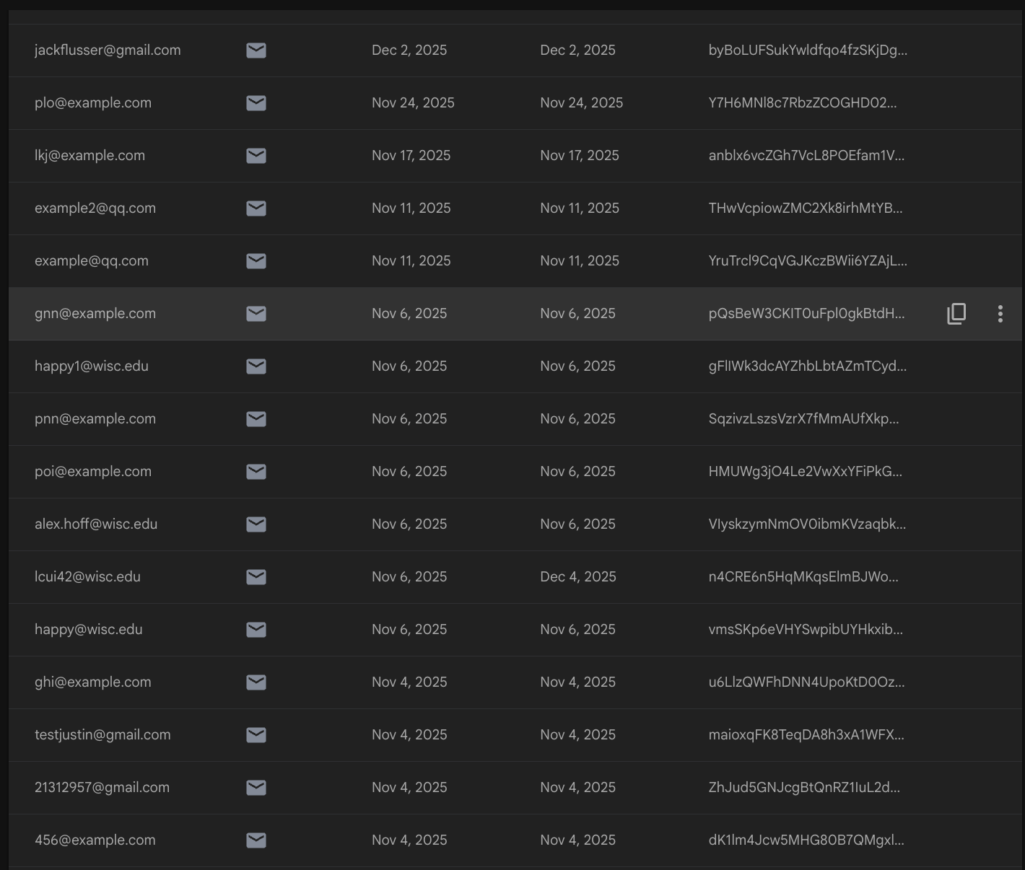
- Show a comprehensive list of all your collections.
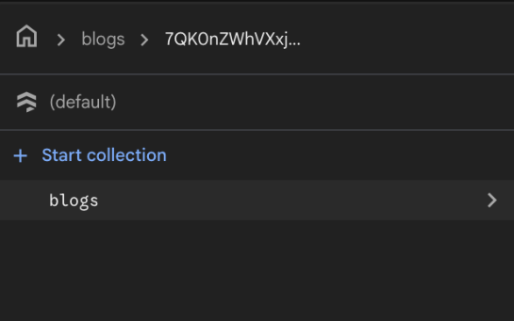

- Show a sample document from each of your collections. For example, if you have 3 collections, provide 3 corresponding screenshots.

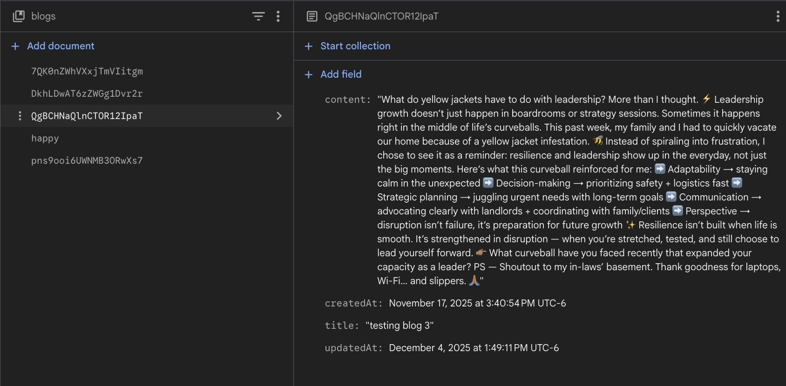
- Show your security rules configuration.
